

BEst. Carpooling. Website. Ever.

Prepared by the Amazing Group 31



CHENG KE JING A0110797B

LAM ZHEN ZONG NICHOLAS A0124238L

LOU CHUN KIT RYAN A0121352X

RIA VERMA A0149253A

TEO QI XUAN A0124206W

**AMAZING ARCHITECTURE**

**Web Server:** Apache

**Server Page Language:** PHP

**Database Management System:** Postgres

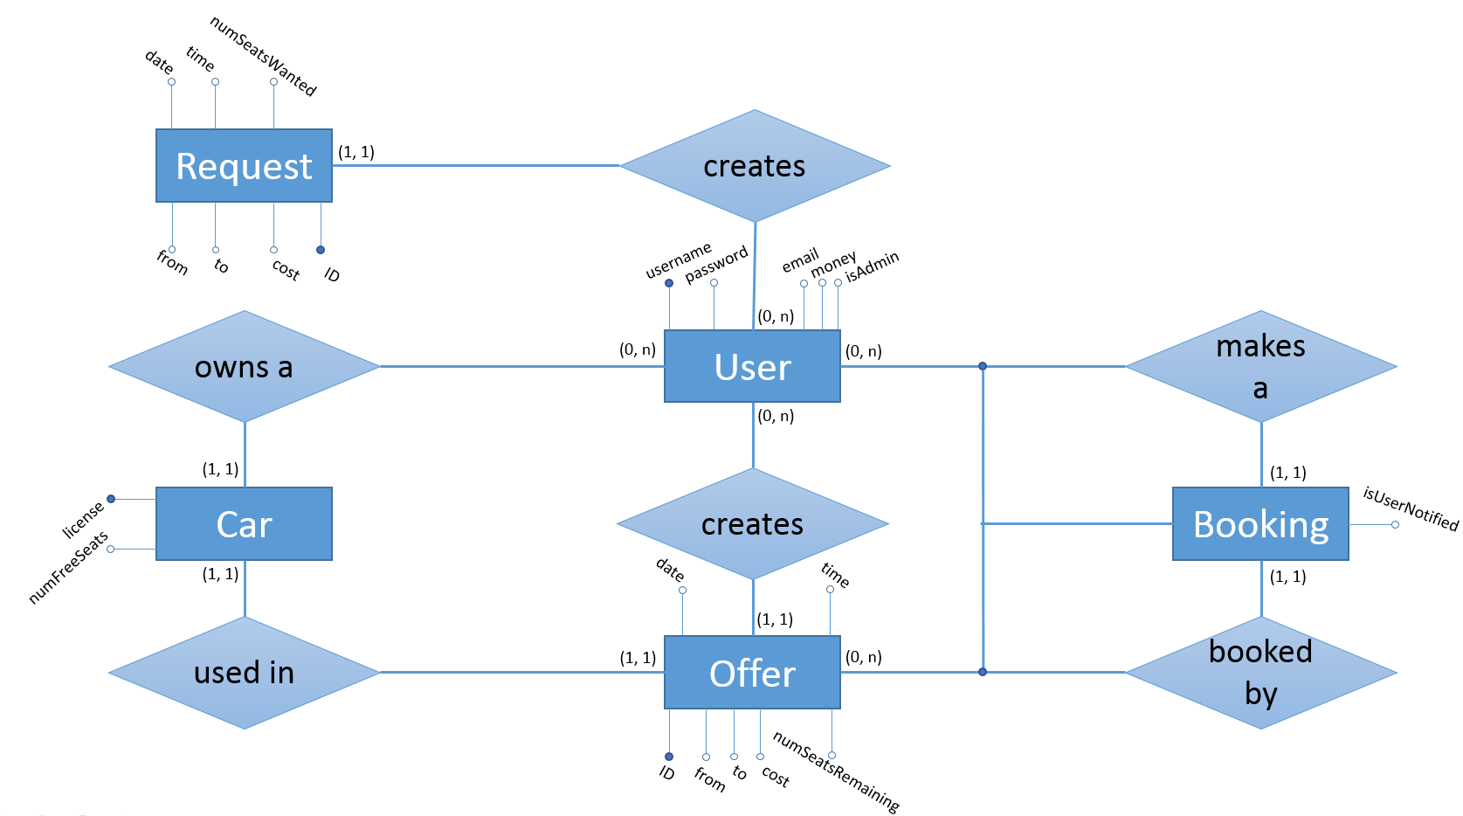**EXCELLENT ER DIAGRAM**

**REMARKABLE RELATIONAL SCHEMA**

CREATE TABLE users(

username VARCHAR(64) PRIMARY KEY,

password VARCHAR(64) NOT NULL,

email VARCHAR(128) UNIQUE,

money numeric NOT NULL,

isAdmin BOOLEAN DEFAULT FALSE

);

CREATE TABLE creates_request(

rid numeric PRIMARY KEY,

fromWhere VARCHAR(128) NOT NULL,

toWhere VARCHAR(128) NOT NULL,

numSeatsWanted numeric CHECK(numSeatsWanted >= 1),

rDate DATE NOT NULL,

rTime VARCHAR(4) NOT NULL,

requestor VARCHAR(64),

FOREIGN KEY (requestor) REFERENCES users(username)

);

CREATE TABLE owns_car(

license VARCHAR(16) PRIMARY KEY,

numFreeSeats numeric CHECK(numFreeSeats >= 1),

cOwner VARCHAR(64) REFERENCES users(username)

);

CREATE TABLE creates_offer(

offerid numeric PRIMARY KEY,

fromWhere VARCHAR(128) NOT NULL,

toWhere VARCHAR(128) NOT NULL,

tripCost numeric NOT NULL,

numSeatsRemaining numeric NOT NULL CHECK (numSeatsRemaining >= 0),

offerDate DATE NOT NULL,

offerTime VARCHAR(4) NOT NULL,

usedCar VARCHAR(16) REFERENCES owns_car(license)

);

CREATE TABLE booking(

isUserNotified BOOLEAN DEFAULT FALSE,

username VARCHAR(64) REFERENCES users(username),

offerid numeric REFERENCES creates_offer(offerid),

PRIMARY KEY (username, offerid)

);

**SUPERB SQL CODE SAMPLES**

SELECT *

FROM creates_offer o

WHERE o.numseatsremaining > 0

AND o.offerdate >= '$date'

AND o.usedcar NOT IN

(SELECT c.license

FROM owns_car c

WHERE c.cowner = '$username')

AND NOT EXISTS

(SELECT * FROM booking b

WHERE b.username = '$username'

AND b.offerid = o.offerid)

The above code fragment is used when the user wishes to looks for currently available offer. The first NOT IN clause prevents users from getting offers which he himself has offered, and the NOT EXIST clause prevents the user from getting offers in which he has already booked.

SELECT COUNT(*)

FROM booking b

WHERE b.username = '$login_session'

AND b.isUserNotified = 'f';

Counts number of unread notification user has with an aggregate query.

**WOW! WEB INTERFACE SCREENSHOTS**

Main Page shows the user his current cash as well as his next three upcoming offers and bookings. If the user has any new notifications (such as a new person booking one of his/her offers), the number next to his name is updated accordingly. He is also able to navigate to other pages using the navigation bar on top. This is done with SQL queries.

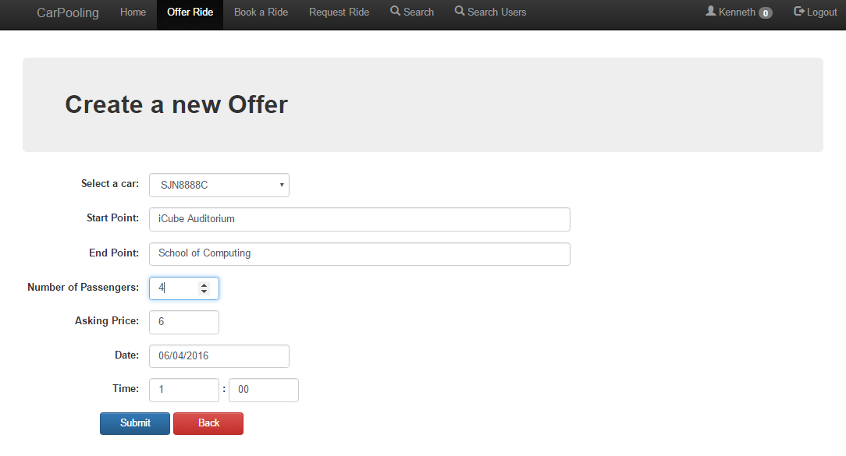

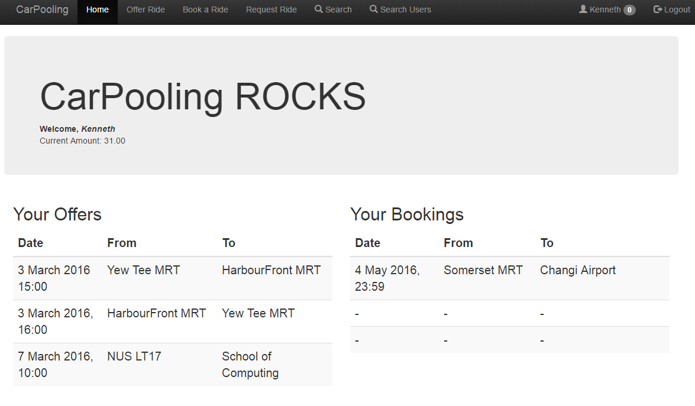

The user is able to create a new offer here. Through SQL integrity constraints, we prevent malicious users from entering nonsense values.

Profile page. User is able to change his personal details here, as well as register his car and top up his funds.

